## APPENDIX 1

**TITLE OF PROJECT:**

**Contact/Address Book Generator**

**END TERM REPORT**

***by***

**Neeraj Saini , Abinash Kakoti , Raviranjan Kumar**

Section: K19PT

Roll-Numbers: 69,67,63



**Department of Intelligent Systems,**

**School of Computer Science Engineering,**

**Lovely Professional University, Jalandhar**

November, 2020

## APPENDIX 2

**Student Declaration**

This is to declare that this report has been written by me/us. No part of the report is copied from other sources. All information included from other sources have been duly acknowledged. I/We aver that if any part of the report is found to be copied, I/we are shall take full responsibility for it.

Signature: Abinash, Neeraj, raviranjan

Name: Abinash kakoti , Neeraj Saini, Raviranjan kumar

Roll Number:67,69,63

Place: Lovely Professional University, Jalandhar

Date:31st November 2020

**APPENDIX 3**

**TABLE OF CONTENTS**

**TITLE:** **Contact/Address Book Generator Page no**

**1.Backgrounds and objectives of project assigned**

**2.Description of the project**

**3.Description Of work division in terms of roles among students**

**4.Technologies and Framework to be used**

**5.Swot analysis achieved in project**

BONAFIDE CERTIFICATE

Certified that this project report “CONTACT/ADDRESS ” is the bonafide work of “Neeraj Saini , Abinash Kakoti, Raviranjan Kumar” who carried out the project work under my supervision.

### <<Signature of the Supervisor>>(Due to Covid 19, signature is exempted )

<<Dr. Dhanpratap Singh>>

<<Assistant Professor>>

<<ID of Supervisor-25760>>

<<CSE>>

1. **Background and objectives of project assigned:**

**The objective of the project is to make a contact /address book generator. In this we will take the information from the user and save it. The information will be like contact number, name , age, gender and address. The output would be the complete information about the user. There will options like “Save” and**

**“Delete” in Contact/Address book. So that the we can save the details of user. If we want to delete the user name permanently from our contact book, there is a delete option in the book which will delete the user details permanently.**

**Main objective is that we can maintain a contact and address databases for user and can access anytime easily.**

1. **Description of Project:**

**This project is helpful to get the information from the user. In this project we get the details of the user like phone number, email, full address, etc. The informatiowhich will be given by the user will be saved successfully.**

**The following will be in the output:**

1. **First name**
2. **Last name**
3. **Gender**
4. **Age**
5. **Address**
6. **Contact**
7. **Save**

**After saving address there is also a “ADD NEW” option. To add new user.**

**If we want to delete any of our contact from our book then there is also “DELETE” option in the book.**

1. **Description of Work Division in terms of Roles among Students:**

**The work is done equally by three of us. We three have designed the project. Neeraj have made some part of address book , Raviranjan also have contributed and made address book generator. Abhinash have made contact book , me and Neeraj also helped in it and made it.**

**The project contain two parts . First part is Contact book generator and Second part is Address book generator, after this we have merged the two into single book generator (i.e.Contact/Address Book Generator).**

**So , we equally contributed to this project**

1. **Implementation of scheduled work of Project:**

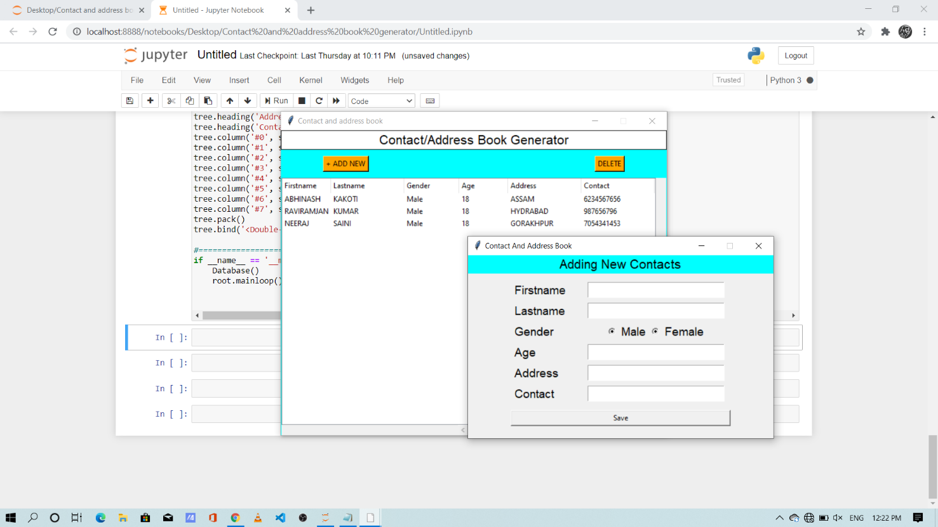

**It is the main page of the Address/Contact book generator. Here we have provided two options “ADD NEW” and “Delete”. By clicking on the ADD NEW we will have the following options on the screen.**

**1.First name**

**2.Last name**

**3.Gender**

**4.Age**

**5.Address**

**6.Contact**

**After getting these information from the user we will save it.**

**It is the output of the Contact/Address Book Generator**

**------**

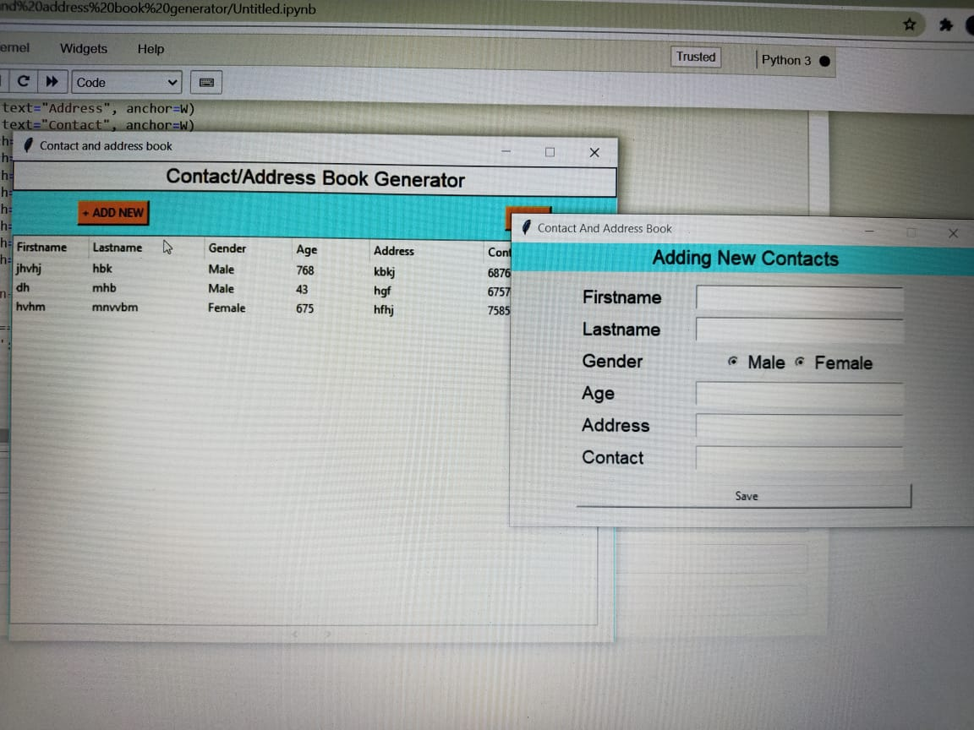

**The following information will be taken from the user and will save it.**

**1.First name**

**2.Last name**

**3.Gender**

**4.Age**

**5.Address**

**6.Contact**

**7.Save**

**After saving we can see the saved contacts on the screen. If we want to delete any of our contact then there is a “DELETE” option on the top right of the screen. From there we can delete our contact permanently.**

1. **Technologies and Framework to be used:**

**Python with tkinter has been used to build this software.**

**The Platform for building this project is Anaconda(Jupytor Notebook).**

**And it also has been tested on Pycharm and Jupyter.**

**And for database system we use sqlite3 .**

1. **SWOT Analysis:**

**Strength: Simple UI.**

**Eye Catching Design.**

**Weakness: No weakness.**

**Opportunities: Easy management of contacts.**

**Threats: The data can be manipulated as the data has not been secured enough.**